# **Need For Cash**

By kendell Rennie and Luis Figueroa

## *Manage your racing team to victory. Make sure they are well funded and have everything they need to win. Avoid scams ,and bad investments to keep your races future safe*

## **Influences (Brief)**

* *Need For Speed*:
  + Medium: *Drag racing game.*
  + Explanation: *Just like Need For Speed this game involves the life of a street racer but you won’t do the racing, instead you will be the racer’s financial agent.*
* *Football manager* 
  + Medium: *PC game*
  + Explanation: *manage your team and draft the best players to win*

## **Core Gameplay Mechanics (Brief)**

*Give a very high-level description of any core gameplay mechanics*

* *Your racer’s car becomes damaged*
* *Racer loses a race*
* *Racer wins a race*
* *Make sure money is available for maintenance, repairs and staff*
* *Recognize bad investments*
* *Take good investments*
* *Know when to borrow from that bank*
* *Have a bank account*

# **Learning Aspects**

## **Learning Domains**

*Briefly list any and all of the disciplines and learning domains for this subject.*

*Managing finances*

## **Target Audiences**

* *College students*
* *High school students*

## **Target Contexts**

*Describe what kinds of formal and informal learning contexts this will be used in (e.g., courses, k-12 computer labs during free time).*

* *Business classes*

## **Learning Objectives**

*Remember, Learning Objectives are NOT simply topics. They are statements of observable behavior that a learner can do after the learning experience. You cannot observe someone "understanding" or "knowing" something.*

* *Analyze the factors that affect financial stability*
* *Create a monthly budget*
* *Will be able to explain what is a bad investment*
* *Demonstrate how to manage financial debt*

## **Prerequisite Knowledge**

*What do they need to know prior to trying this game?*

* *They need to know basic linear algebra*

## **Assessment Measures**

*Each level will have specific life situations that the player will have to make specific decisions on to improve the racer’s finances and prevent them from going broke.*

# **What sets this project apart?**

*Give some reasons why this game is not like every other game out there. Whether the learning objective is unique, the gameplay mechanics are new, or what. You should persuade the reader that your game is novel and worthy of development. Consider arguments that would be persuasive to a Venture Capitalist, Teacher, or Researcher. These might be focused on learning needs, too.*

* *This is one of the only racing games where you aren’t doing the racing*

# **Player Interaction Patterns and Modes**

## **Player Interaction Pattern**

* *This game is for one player where they are clicking their decisions in the game.*

## **Player Modes**

*Your game has one or more player modes. Describe each discrete mode, considering things like menus too. Generally describe the transitions between modes too.*

* *Player mode #1*: *Agent mode; you’re a financial agent and have to make sure your racer doesn’t run out of money between each race as they excel to each competition*
* *Player mode #2: Race mode; you’re the racer and this isn’t unlocked until you’ve completed the agent mode*

# **Gameplay Objectives**

* *Primary Objective #1*: Avoid bankruptcy
  + Description: financing repairs and staff will be expensive so don't overreach
  + Alignment:
* *Primary Objective #2*: Advance to the next level
  + Description: *as your racer wins more you get more prize money. Choose where the racer wil race next.*
  + Alignment: *As you advance each level, your competition becomes more fierce*
* *Primary Objective #3:Avoid scams and bad investments*
  + *Description: as you level up there will be more opportunities to gain capital there will also be more risky and binding investments*

# **Procedures/Actions**

# 

# **Rules**

*What resources are available to the player that they make use of? How does this affect gameplay? How are these resources finite?*

*The player will start off with some money and a racer. They must manage the team to victory.*

# **Objects/Entities**

* *The cars.*
* *The maintenance staff and driver.*
* *Banks and investors*
* *Credit score.*

## **Core Gameplay Mechanics (Detailed)**

* *Take you car and racers to games and hop they win money*
* *Use that money for upgrades and larger capital*
* *Pick the right investment without going bankrupt*

## **Feedback**

*Explicitly describe what visual/audio/animation indicators there are that give players feedback on their progress towards their gameplay objectives (and ideally the learning objectives).*

*Describe what longer-term feedback you detect and give that guides the player in their learning and lets them know how they are doing in regards to the learning objectives.*

* *When you are losing money your money bar is red*
* *When you gain money your bar turns green*
* *Your racer performs better in races if you upgrade his car*

# **Story and Gameplay**

## **Presentation of Rules**

*Briefly describe how the player will learn the gameplay mechanics. Avoid using walls of text, since people will not read them. Think instead of natural ways of teaching mechanics iteratively and slowly.*

*During the beginning stages of the game there would be a tutorial where the game would highlight what the player could click on and explain its purpose in the game.*

## **Presentation of Content**

*Briefly describe how the player will be taught the core material they are meant to learn. Avoid using walls of text, since people will not read them. Think instead of natural ways of teaching material iteratively and slowly.*

* *By incorporating financial jargon within gameplay such as “interest rate”, “APR” and credit score.*

## **Story (Brief)**

*The Summary or TL;DR version of below*

*You must use your monetary wits to guide your drag racer to victory not on the race track but in the financial world.*

## **Storyboarding**

*Go into as much detail as needs be to visually convey the Dynamics of your game. Be detailed. Create storyboards and freeze frame images that concisely capture important key elements of your game. You are strongly recommended to sketch pictures on paper and embed them here. Be sure make it clear how previously-described mechanics come through in the dynamics.*

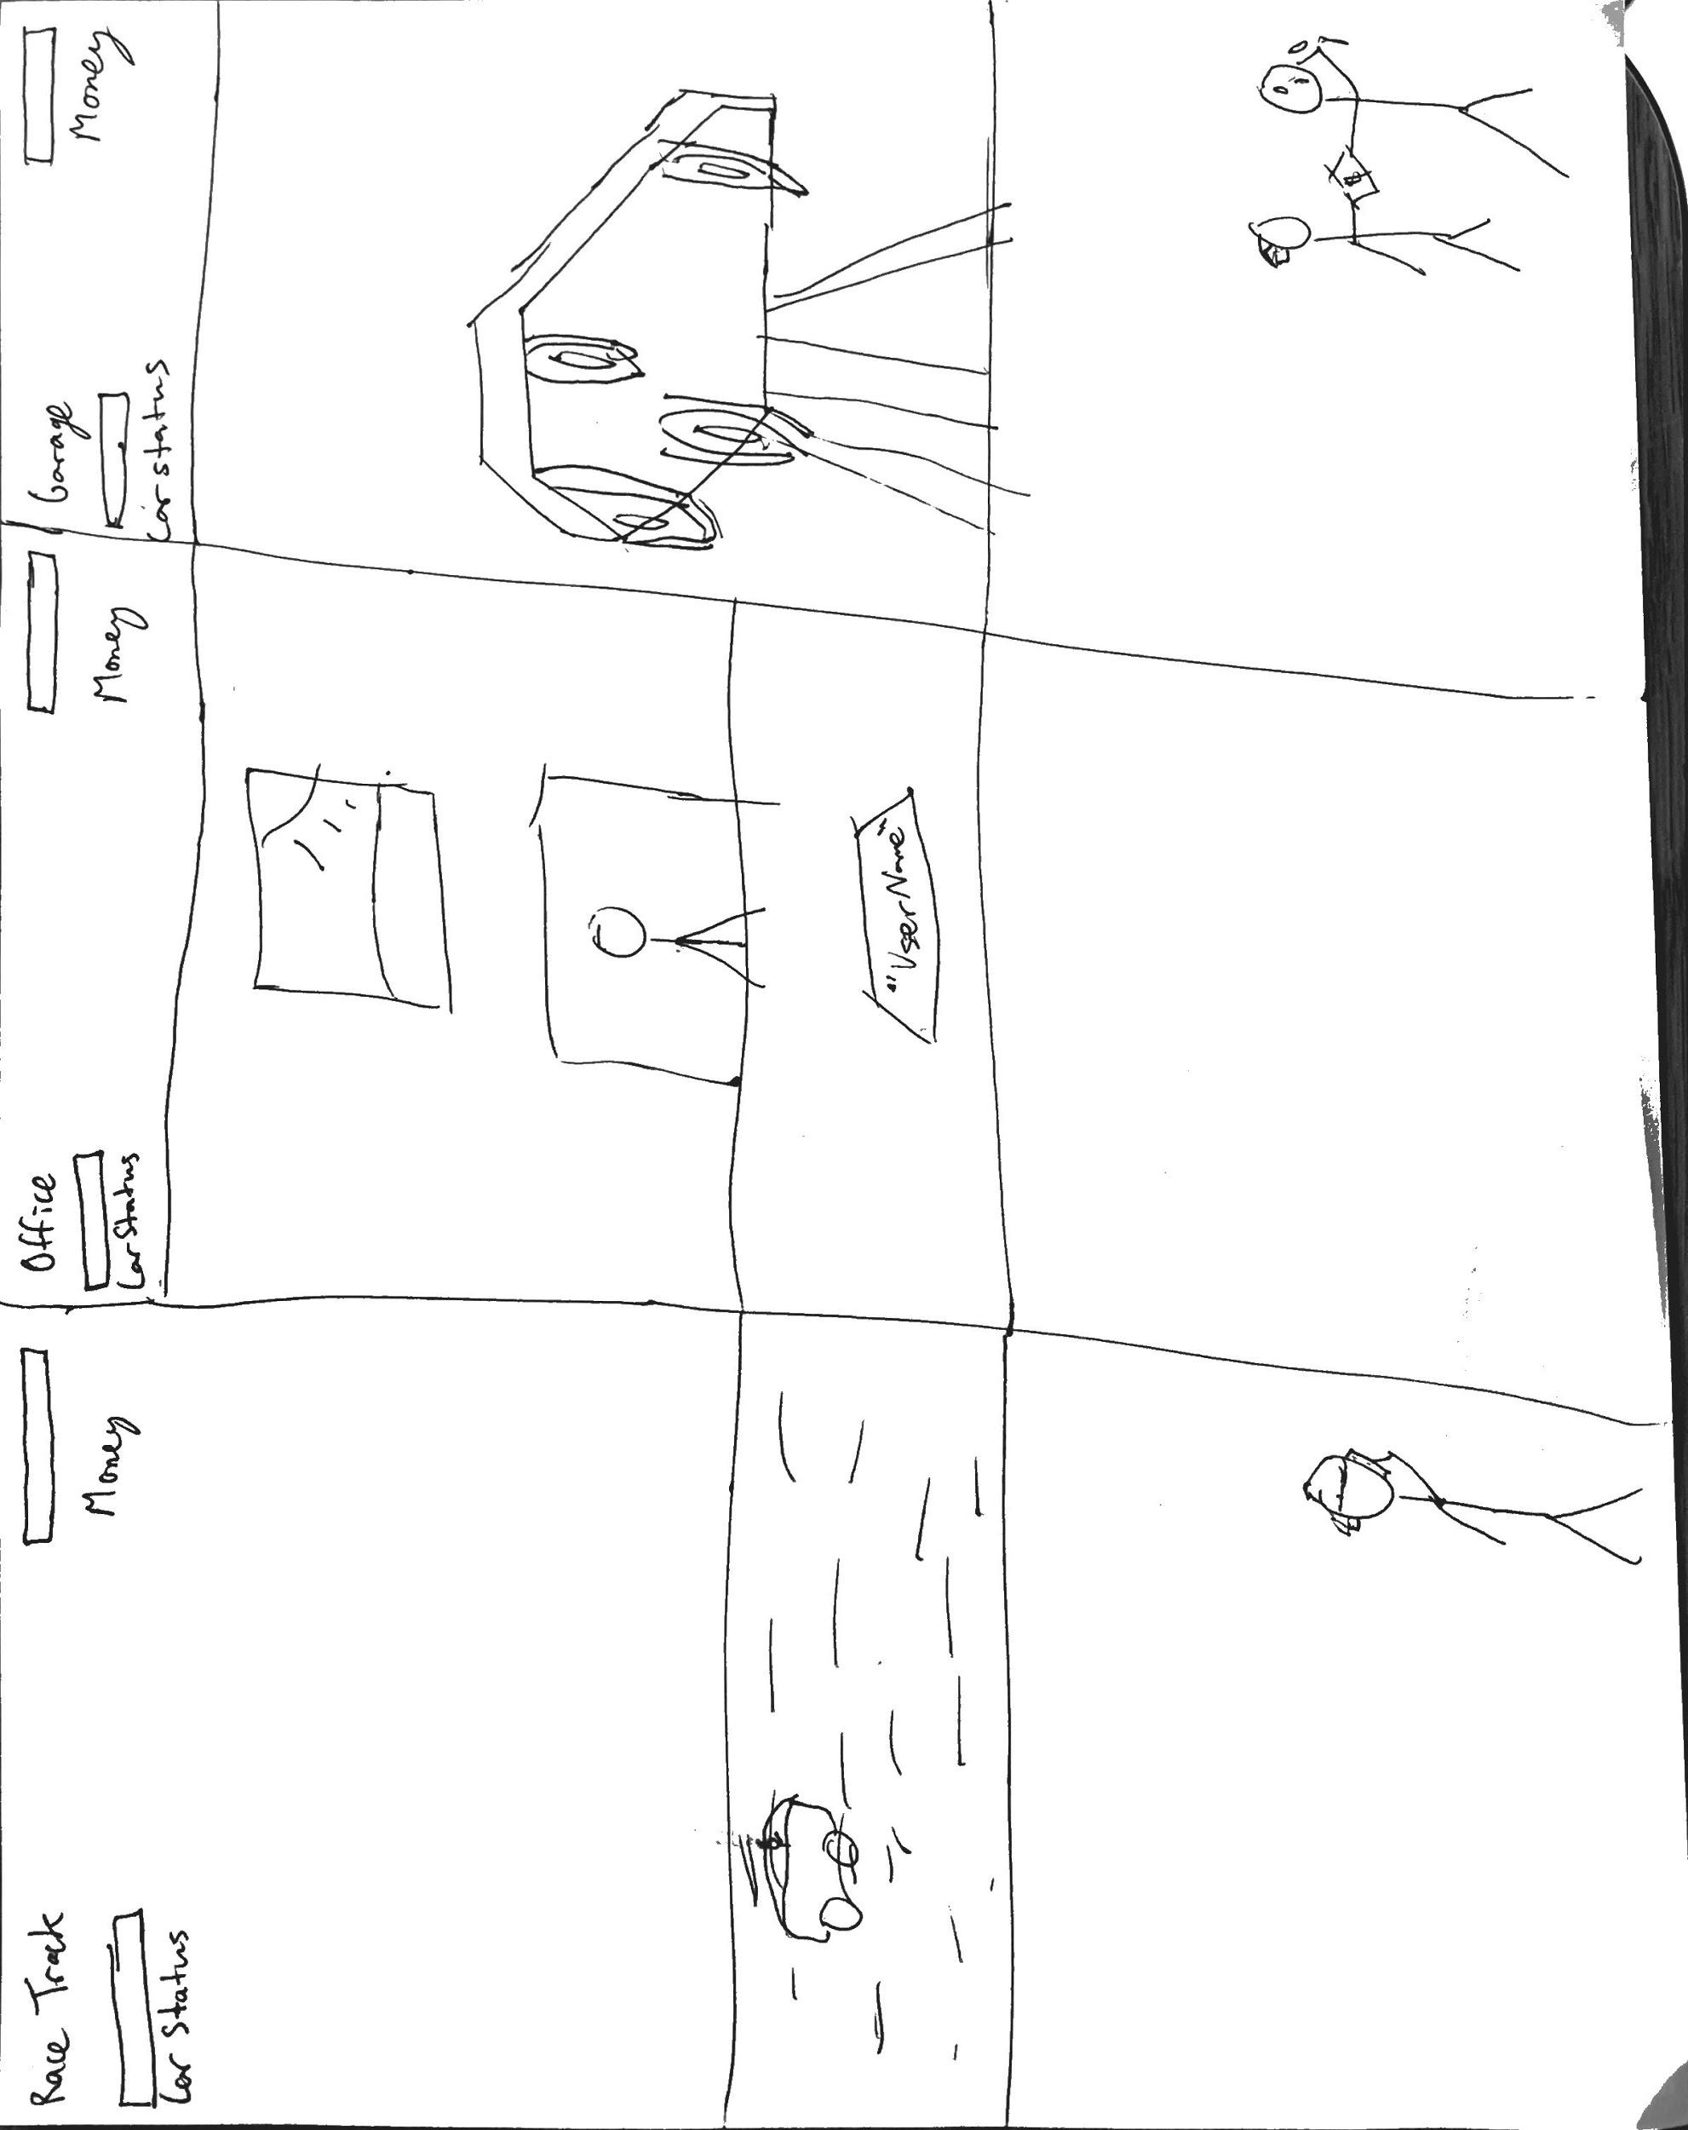

# **Assets Needed**

## **Aesthetics**

*Give a sense of the aesthetics of your game, the spirit and atmosphere. Use descriptive, evocative words that can help the reader understand the emotional response of your game.*

*Depending on the time we have left it will be a blank white background with stick figures as characters.Or it will have detailed pixel art characters with a background* **Graphical**

* Car garage
  + Car *(main character)*
  + *Car states*
  + *Damages and maintenance repair*
* Textures:
  + *Stick figures*
* Environment Art/Textures:
  + *White background*
  + *Or*

## **Audio**

*Game region/phase/time are ways of designating a particularly important place in the game.*

* Music List (Ambient sound)
  + *General gameplay*: Sekiro music

*Game Interactions are things that trigger SFX, like character movement, hitting a spiky enemy, collecting a coin.*

* Sound List (SFX)
  + *Car sounds*
  + *Wrenching and hammer sounds*
  + *Money sounds*

# **Metadata**

* Template created by Austin Cory Bart acbart@udel.edu, Mark Sheriff, Alec Markarian, and Benjamin Stanley.
* Version 0.0.3